

# Perth Modern School

### Semester Two Examination, 2019

### Question/Answer Booklet

**12 METHODS**

**UNITs 3 & 4**

## Section Two:

## Calculator-assumed

Your name

Your Teacher’s name

## Time allowed for this section

Reading time before commencing work: ten minutes

Working time for section: one hundred minutes

## Materials required/recommended for this section

***To be provided by the supervisor***

This Question/Answer Booklet

Formula Sheet (retained from Section One)

***To be provided by the candidate***

Standard items: pens (blue/black preferred), pencils (including coloured), sharpener, correction fluid/tape, eraser, ruler, highlighters

Special items: drawing instruments, templates, notes on two unfolded sheets of A4 paper, and up to three calculators approved for use in the WACE examinations

## Important note to candidates

No other items may be taken into the examination room. It is **your** responsibility to ensure that you do not have any unauthorised notes or other items of a non-personal nature in the examination room. If you have any unauthorised material with you, hand it to the supervisor **before** reading any further.

|  |  |  |  |  |  |
| --- | --- | --- | --- | --- | --- |
| **Question** | **Marks** | **Max** | **Question** | **Marks** | **Max** |
| **8** |  | **4** | **15** |  | **8** |
| **9** |  | **9** | **16** |  | **8** |
| **10** |  | **6** | **17** |  | **7** |
| **11** |  | **9** | **18** |  | **10** |
| **12** |  | **6** | **19** |  | **6** |
| **13** |  | **9** | **20** |  | **10** |
| **14** |  | **8** | **21** |  | **5** |

Structure of this paper

|  |  |  |  |  |  |
| --- | --- | --- | --- | --- | --- |
| Section | Number of questions available | Number of questions to be answered | Working  time (minutes) | Marks available | Percentage of exam |
| Section One:  Calculator-free | 7 | 7 | 50 | 50 | 35 |
| Section Two:  Calculator-assumed | 14 | 14 | 100 | 105 | 65 |
|  | | | **Total** | 155 | 100 |

## Instructions to candidates

1. The rules for the conduct of examinations are detailed in the school handbook. Sitting this examination implies that you agree to abide by these rules.
2. Write your answers in this Question/Answer Booklet.
3. You must be careful to confine your response to the specific question asked and to follow any instructions that are specified to a particular question.
4. Spare pages are included at the end of this booklet. They can be used for planning your responses and/or as additional space if required to continue an answer.

* Planning: If you use the spare pages for planning, indicate this clearly at the top of the page.
* Continuing an answer: If you need to use the space to continue an answer, indicate in the original answer space where the answer is continued, i.e. give the page number. Fill in the number of the question that you are continuing to answer at the top of the page.

1. **Show all your working clearly**. Your working should be in sufficient detail to allow your answers to be checked readily and for marks to be awarded for reasoning. Incorrect answers given without supporting reasoning cannot be allocated any marks. For any question or part question worth more than two marks, valid working or justification is required to receive full marks. If you repeat any question, ensure that you cancel the answer you do not wish to have marked.
2. It is recommended that you **do not use pencil**, except in diagrams.
3. The Formula Sheet is **not** to be handed in with your Question/Answer Booklet.

Section Two: Calculator-assumed (105 Marks)

This section has**thirteen (****14)** questions. Answer **all** questions. Write your answers in the spaces provided.

Working time for this section is 100 minutes.

Question 8 (4 marks)

The area of a triangle can be found by the formula $Area=\frac{1}{2} ab\sin{C}$. Using the incremental formula, determine the approximate change in area of an equilateral triangle, with each side of 5 cm, when each side increases by 0.2 cm.

Question 9 (9 marks)

1. The probability of Australian Year 12 students obtaining their driver’s licence is thought to be around 65%. How large a sample of students should be used to establish this within a margin of error of 5% at the 90% confidence level? (3 marks)
2. A survey of 1000 Australians renting houses found that 35% of their income was paid in rent.
3. Estimate the standard deviation of the sampling distribution. (2 marks)
4. What z-score should be used for an 80% confidence interval? (1 marks)
5. Estimate the 80% confidence interval for the proportion of income used for renting in Australia. (3 marks)

Question 10 (6 marks)

Let  .

1. Determine  using the quotient rule. (3 marks)

1. Sketch  on the axes below showing any intercepts and asymptotes. (3 marks)

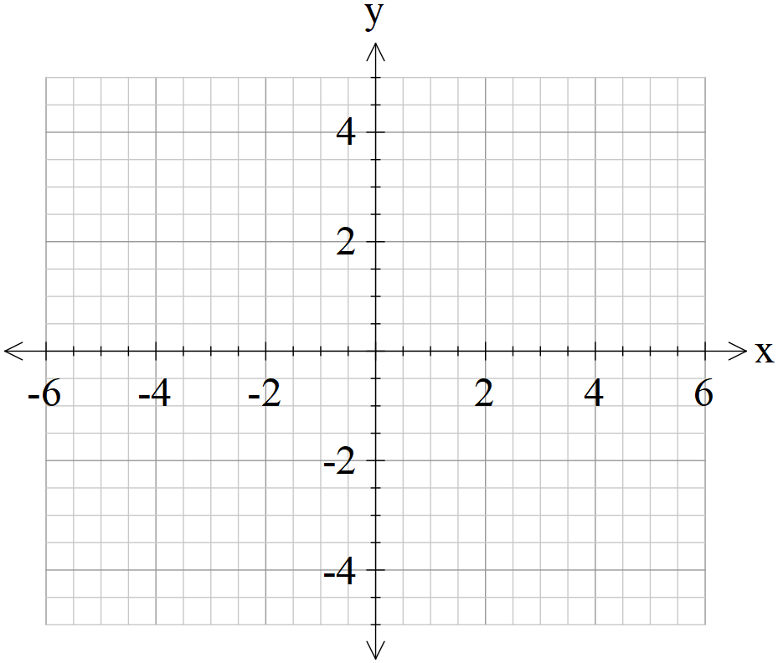

Question 11 (9 marks)

In a general population, 15% of people are left-handed. A class has 32 students and number of who are left-handed is counted. Let  = number of left-handed students in a class of 32 students.

1. State and describe the type of distribution of. (3 marks)
2. How many in the class would you expect to be left-handed? (1 mark)
3. What is the probability that the number of left-handed students in the class is within one standard deviation of the mean? (3 marks)
4. Find the probability that at most half of the class are left-handed. (2 marks)

Question 12 (6 marks)

The equation  is used to describe the acceleration,  metres per second squared at time  seconds, of a weight at the end of a spring. Initially the weight is at rest at the origin.

1. Find the velocity of the weight after $\frac{π}{4}$ seconds. (3 marks)
2. Find its displacement from the origin after $\frac{π}{2}$ seconds. (3 marks)

Question 13 (9 marks)

A chocolate factory makes bars of chocolate such that the mass of these bars forms a normal distribution of mean mass of 35 grams and a standard deviation of 4 grams. Only those bars that have a mass within 1.5 standard deviations are usually sent to stores for sale.

1. Determine the probability that a bar of chocolate produced, will be usually sent to a store for sale. (3 marks)

In December each year, the person who’s job is to check the mass of bars is on holiday and no one replaces their role. The bars of chocolate are packed in boxes of 50.

Let  = number of bars suitable for sale in a box of 50 in December.

1. State the distribution for giving the mean and standard deviation. (3 marks)
2. Determine the probability that in a given box of 50 that at least 40 are suitable for sale in December. (2 marks)

1. It is decided to employ a part time worker in December to select boxes of 50 at random to check the number of bars that are suitable for sale. State a method for randomly selecting these boxes for inspection. (1 mark)

Question 14 (8 marks)

For the following questions, show using calculus how to determine an optimal solution.

1. Determine two positive numbers, $x$ and $y,$ whose product is 36 and such that $2x+y$ is a minimum.

(4 marks)

1. Find the area of the largest rectangle of lengths  that can be enclosed in a circle of radius $r.$

(4 marks)

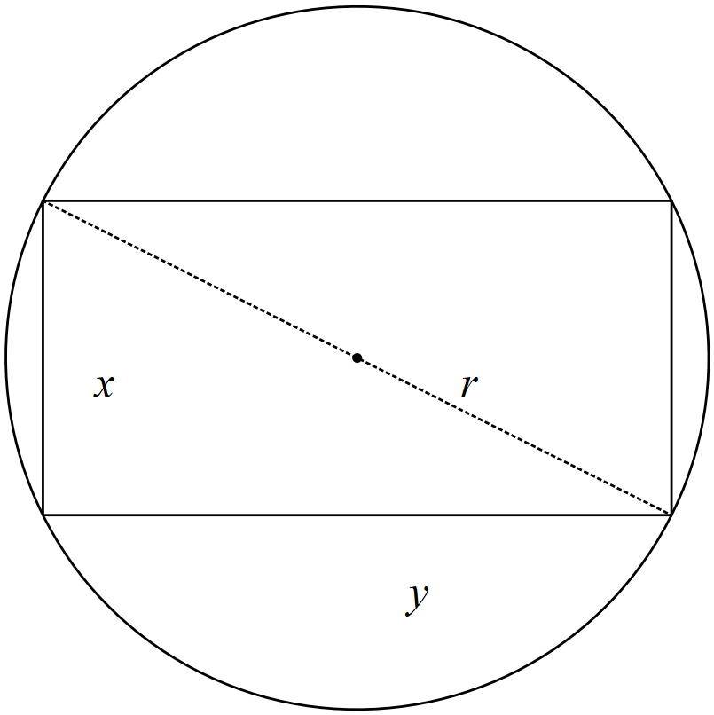

Question 15 (8 marks)

A game consists of a wheel divided into sixteen equal sectors numbered 1 through 16. You may place a $2 bet on any number. If your number comes up, you get $20 back. That is, you win $18 after getting your $2 back. If you lose then you have lost $2.

1. Let $X$ be the amount of profit won on a bet by the player. Find the amount the player expects to profit on a bet. i.e , explain what this means. (3 marks)

|  |  |  |
| --- | --- | --- |
| $$x$$ |  |  |
| $$P(x)$$ |  |  |

1. Determine the standard deviation of , amount of profit won on a bet by the player (3 marks)
2. How much should you **win** for the game to be fair? ($E(X)=0$) (2 marks)

Question 16 (8 marks)

The displacement, , in centimetres of a particle from the point O in a straight line is given by

$x\left(t\right)=\frac{1}{2}{\left(\frac{t}{3}-4\right)}^{2}-2$ for $0≤t≤12$, where $t$ is measured in seconds.

Calculate the:

1. Time(s) that the particle is at rest. (2 marks)
2. Displacement of the particle during the sixth second. (2 marks)
3. Maximum speed of the particle and the time when this occurs. (2 marks)
4. Total distance travelled in the first 12 seconds. (2 marks)

Question 17 (7 marks)

A school has analysed the exam scores for all Year 12 Methods students and found that the mean was 76 with a standard deviation of 21. Let $X$ be the exam scores out of a 100. Determine the following.

1. $E(X-6)$ (1 mark)
2. $Var (10-2X)$ (2 marks)

The school has decided to scale the results down to mean of 65 and standard deviation of 15, using the transformation $Y=aX+b$ where $a$ and $b$ are constants and $Y$ is the scaled percentage scores.

(c) Determine the value(s) of $a$ and $b$. (4 marks)

Question 18 (10 marks)

A government agency is investigating the number of motor vehicles in Perth that are producing an illegal amount of pollution. In a sample of 350 motor vehicles, 35 where found to produce an illegal amount of pollution.

1. Calculate the sample proportion of vehicles that are illegally polluting. (1 mark)
2. Determine an 85% confidence interval of the true proportion of vehicles illegally polluting to four decimal places and state the margin of error, (4 marks)
3. Determine the probability that in a random sample of 350 vehicles, the proportion of polluting vehicles lies between 0.08 and 0.12. (2 marks)
4. Below are three samples of vehicles, one of them is actually from another country. Which one is most likely not to be in Perth and give reasons. (3 marks)

(Continue with a confidence of 85%)

|  |  |  |
| --- | --- | --- |
| Sample A  44 polluting vehicles out of a sample size of 340 | Sample B  20 polluting vehicles out of a sample size of 280 | Sample C  50 polluting vehicles out of a sample size of 420 |

Question 19 (6 marks)

The diagram below shows the graph of $y=(x+1)(x-1)(x-d)$ with constant $d$ where $d>1.$ The graph intercepts the y-axis at the point A.

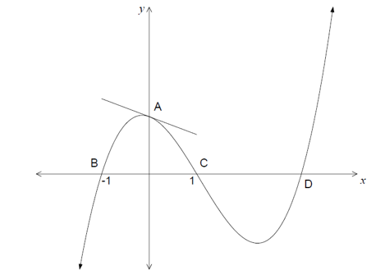

$$(d,0)$$

1. Find the equation of line $AD$ in terms of $d$. (2 marks)
2. Show that a line that passes through $A$ and $D$ is tangent to the graph at $A$. (4 marks)

**Question 20 (10 marks)**

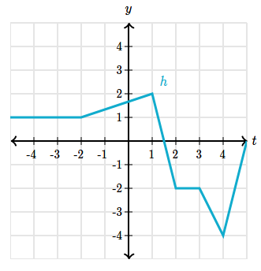

The graph of $h(x)$ is shown on the right.

1. Evaluate the following definite integrals
2. $\int_{-2}^{1}{h^{'}\left(x\right) dx}$ (2 marks)
3. $\int_{2}^{3}{{10h}^{'}\left(x\right) dx}$ (2 marks)
4. $\int_{-2}^{4}{{(h}^{'}\left(x\right)+1) dx}$ (2 marks)
5. Find the area bounded by the graph of $h^{'}(x)$ and the $x$ axis between $x=-2$ and $x=4$. Justify your answer. (4 marks)

Question 21 (5 marks)

Let $g\left(x\right)=\int_{-2}^{x}{ f\left(t\right) dt }$ with $g\left(2\right)=20$ and $\frac{d^{2}g}{dx^{2}}=6x.$ Determine the function $f(x)$.

Additional working space

Question number: _________

Additional working space

Question number: _________

Additional working space

Question number: _________